CONFERENCE 2023

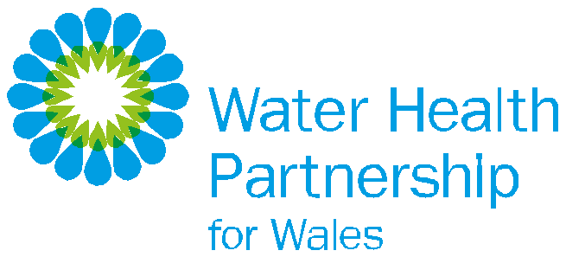
9th NOVEMBER 2023 | CEFN LEA CONFERENCE CENTRE, DOLFOR, NEWTOWN SY16 4AJ

AGENDA

09:30 Refreshments on arrival

10:00 Welcome / Housekeeping / Aims for the day
Sharon Evans, Director of Quality Policy and Compliance, Dŵr Cymru Welsh Water and Chair, Water Health Partnership Conference morning session

10:15 Welsh Government Policy update
Claire Fernandes, Deputy Director, Welsh Government

10:30 Emerging Risks
- Presentation (Adriana Kiss, Welsh Government)
- Update on PFAS monitoring in Wales (Jennifer Gray, Dŵr Cymru Welsh Water),
& (Julia Mansbridge, Natural Resources Wales)

11:00 Break

11:15 Water Incident Management
Cryptosporidium and the Communicable Disease Outbreak Plan
(Workshop / Scenario / Learning)

12:15 – 13:15 Lunch
During lunchbreak delegates are encouraged to network

13:15 Introduction to afternoon session
Oliver Twydell, Water Regulations and Public Health Business Leader, Hafren Dyfrdwy and Chair, Water Health Partnership Conference afternoon session

13:20 Private Water Supplies and Wider Water Supplies in Wales
Marcus Rink, Chief Inspector, Drinking Water Inspectorate

14:10 Exploring health risks and impacts of the use of private water supplies in Wales, in the context
of a changing climate
Anna Schwappach and Kristian James, Public Health Wales

14:50 Break

15:05 Questions and feedback

15:35 Closing Remarks
Sharon Evans, Director of Quality Policy and Compliance, Dŵr Cymru Welsh Water

15:45 Event Close

SPONSORED BY
